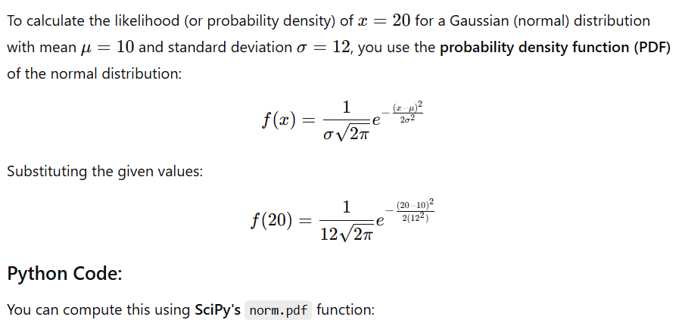

import scipy.stats as stats

# Given parameters

mu = 10 # Mean

sigma = 12 # Standard Deviation

x = 20 # Value we want the likelihood for

# Compute the probability density

likelihood = stats.norm.pdf(x, mu, sigma)

print("Likelihood of 20:", likelihood)